INTRODUCTION TO PROJECT

The web and mobile based “Smart Ordering and Payment System” project is an attempt to stimulate the basic concepts of ordering and payment system for cafe and restaurants. The system enables the customer to do the things such as ordering , watch recent orders , manage account and pay directly from application or Android aap. The system provides you Quick menu list which is served by cafe or restaurants and facility that provides you to order and pay without standing in a queue . This facility available in Android application as well as desktop application.
The system allows admin (owner of cafe and restaurant) to manage menu-list, category-list, user-list, payment-history, order-list specified by userId which is a unique id for customer to manage record. Admin panel has all the admin related support and permissions to manage the all the functions required to manage users.
Same user feature available for android application as well as desktop application both are available as we choose to use which platform we have managed the database for both applications using same databases for functioning . As we all know we faces lot of problems when we went to cafe or restaurant and there is a rush so it take quite long time to full fill the order and payment but using smart ordering and payment system we can make it easier and transparent and admin can manage all the orders and payment just sitting at his desk.
To manage the database of smart ordering and payment system every order are record with the time and date when it placed by user which makes it easier to manage. The Admin as well as user panel is build using MEAN technology and user panel is build using MEAN as well as Android technology for the users. The database technology used is MySQL.

2.REQUIREMENTS

2.1 FUNCTIONAL REQUIREMENTS

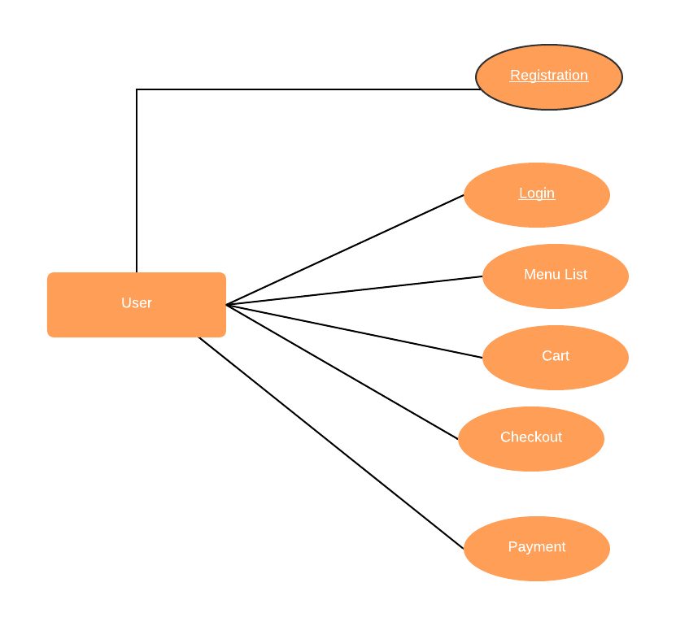
2.1 User Account

The customer is served as ‘user’ in this project user have similar contains which are necessary for the online shopping and ordering products from e-commence user have to fill basic info like name, mobile number, email, etc for registration and then need to login to use services. After login user gets menu list which is shown by the admin.
The user gets the unique id for the identification because when user logged in the userid is used for all the process user are going through so we can maintain the cart and checkout as well as payment detail for the particular user.

2.2 Registration and creation of user profile

The registration process is must for the every user so we can maintain the record. Registration of user is must for the user to use the all user services so that we can get the services. Registration process gone through taking information from user like mobile number, email, name, etc so we can get contact with user using email, offer and etc
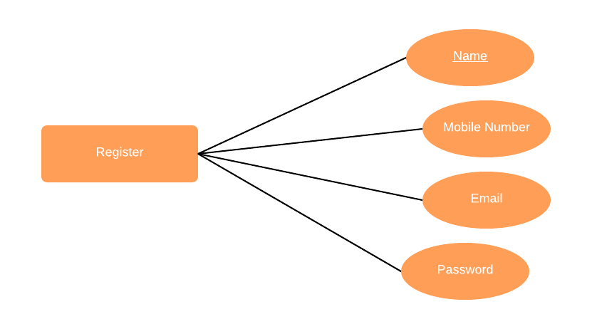

  - Menu List
Menu list is shown to user after login the first screen is menu list where we can add the menu we want to order so it has a list of items. For admin the preferences are given to add menu, delete menu, update menu as per the availability. Admin has more role than the user in this sections because admin has the important role to show which menu items are available or not and which menu items are changed etc.

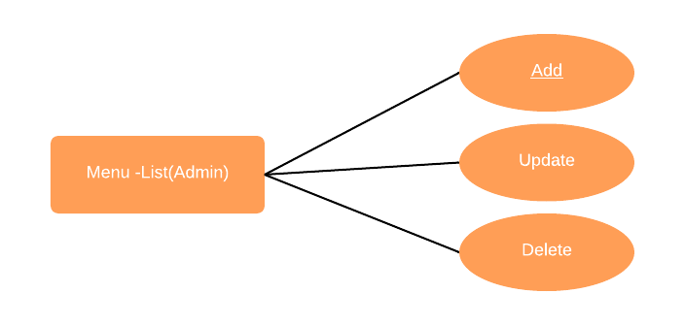

  - Add to cart and checkout:-
User can add the selected menu items in user cart which maintain unique id I.e userid in which the selected items are added and the price is added accordingly te items in the cart.
- User can add the item quantity in cart.
- User can delete the items in the cart.
According to above operation the price is increases and minimizes accordingly the operation is performed the GST rates are applied in checkout order items where user will get final price of the product move to the payment page.

2.5 Order History
User will get the facility to check his previous data of payment and order and can be shown date and time. To give user his particular history of payment, order, etc we maintain the userid for all the process so all data is maintain for the user and the mismatching of data avoided.

2.6 Admin Panel
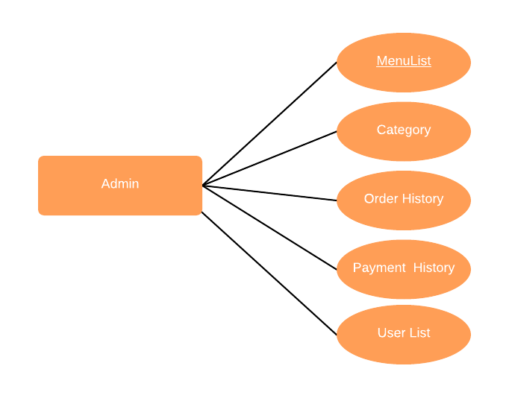
Admin panel has a login. After login admin have all the control on the access to the above component. Admin can perform CORS operation on each model he has access. Admin basically monitor all the activities, manages them and update them as required.

  - NON FUNCTIONAL REQUIREMENTS

2.2.1 Technology
We used Mean stack development for admin as well as user components and Android technology for user panel.

2.2.2 Performance
- Number of Concurrent Users:
We used MEAN technology as a backend so the all the request are so fast because we use backend as node.js
- Menu order:
Using MEAN and Android user panel are build both way operation is performed backend is express server which manages all the responses.

2.2.3 Mysql database:

Mysql is powerful database which used in this technology for the database operation. Mysql provide strong query support to handle tricky query applications.

2.2.4 Other Requirements:
- To deploy on AWS
To use Admin and user panel we need to deployed the application on AWS so that we can access it from anywhere using url.
- Android App
Android application is only for the user section which communicate with the backend express service so it works on the same express server on which the admin and user desktop versions are used.

3. DESIGN

3.1 Database Design

The following table structures depict the database design. The description of every table is as follows,

Table1: User:-

Field | Type | Null | Key | | Extra
id | int(11) | NO | PRI | auto_increment
name | varchar(100) | YES | 6 | 1
email | varchar(100) | YES | 255 | 1
phone | varchar(10) | YES | 255 | 1
password | varchar(100) | YES | 255

Table2: Administrator_Login:-

Field | Type | Null | Key | | Extra
email | varchar(100) | YES | - | -
password | varchar(100) | YES | - | -

Table3: Menu_list:-

Field | Type | Null | Key | | Extra
category_id | int(11) | YES | MUL | -
menu_id | int(11) | NO | PRI | auto_increment
menu_name | varchar(50) | YES
price | int(11) | YES | - | -

Table4: Category:-

Field | Type | Null | Key | | Extra
category_id | int(11) | PRI |  | auto_increment
category_name | varchar(50) | YES | - | -

Table5: cart:-

Field | Type | Null | Key | | Extra
cart_id | Int(11) | NO | PRI | auto_increment
id | Int(11) | YES | - | -
menu_id | Int(11) | YES | - | -
menu_name | varchar(100) | YES | - | -
price | Int(11) | YES | - | -

Table6:Checkout:-

Field | Type | Null | Key | | Extra
checkout_id | Int(11) | NO | PRI | auto_increment
id | Int(11) | YES | - | -
date | DateTime | YES | - | -
Total_test | Int(11) | YES | - | -
Total_test | Int(11) | YES | - | -

Table6:Payment:-

Field | Type | Null | Key | | Extra
pay_id | Int(11) | NO | PRI | auto_increment
id | Int(11) | YES | - | -
datetime | DateTime | YES | - | -
Total_test | Int(11) | YES | - | -
payment_mode | varchar(100) | YES | - | -

E-R Diagram,Dataflow diagram and Class Diagram:

Go to Appendix A

4. TEST REPORT

Another group called Linux did the testing and the report of the testing is given hereunder.
GENERAL TESTING:
SR-NO | TEST CASE | EXPECTED RESULT | ACTUAL RESULT | ERROR MESSAGE
1 | Register Page | Redirected to Next page | OK | Nothing
2 | Login Page | Pop-up will come | Ok | Please enter username and password again .
3 | Reset login | Only users password will be reseted | Ok | Nothing
4 | Menu list | Gives all menu details | Ok | Nothing
5 | Add to cart | Button given to add | Ok | Nothing
6 | Checkout sec | Total other info | Ok | Nothing
7 | Payment sec | Payment final price | Ok | Nothing
8 | Pay method | Method tested | Ok | Nothing
9 | Admin Login | Admin login sec | Ok | Nothing
10 | Admin policies | Cors operations | Ok | Nothing
11 | Userlist for admin | Managing users | Ok | Nothing
12 | Logout | It will logout from admin and user profile. | Ok | Nothing

5. PROJECT MANAGEMENT RELATED STATISTICS

DATE | WORK PERFORMED | Support | Additional Notes
JAN 12,2020 | Project Allotment and User Requirements Gathering | Feasibility Study | Project allotment
JAN 17,2020 | Basic structure for building project with lab faculty support. | Basic google search | Basic building structure
JAN 18,2020 | Designing the use-cases, Class Diagram, Collaboration Diagram, E-R Diagram and User Interfaces | Requirement Analysis &  Design Phase | Database Design completed
JAN 19,2020 | Business Logic Component design Started | Design Phase | ----------------------
JAN 20,2015 | Coding Phase Started | Coding Phase | Backend started in express
JAN 21,2020 | Implementation of Web Application | Coding Phase | Fronted and backend done
JAN 22, 2020 | Implementation of android aap | Basic structure | Design started build up
JAN 23, 2020 | Implementation of Web Application and Android aap continued…. | Coding Phase and Unit Testing | Class Library Modified as per the need.
JAN 24, 2020 | Implementation of Web Application and Android aap continued…. | Coding Phase and Unit Testing | --
JAN 25, 2020 | Implementation of Web Application and Android aap continued added functions | Coding Phase and Unit Testing | Module Integration was done by the lab faculties
JAN 26, 2020 | implementation of Web Application and Android aap continued added functions tested | Testing Phase (Module Testing) | --
JAN 27, 2020 | implementation of Web Application and Android aap continued added functions tested and video tested | Testing Phase (Acceptance Testing) | Project video testing
JAN 28-29, 2020 | The Errors Found were Removed | Debugging | The Project was complete for submission
JAN 30, 2020 | Final Submission of Pro

Homepage: Select Admin or User Login:-
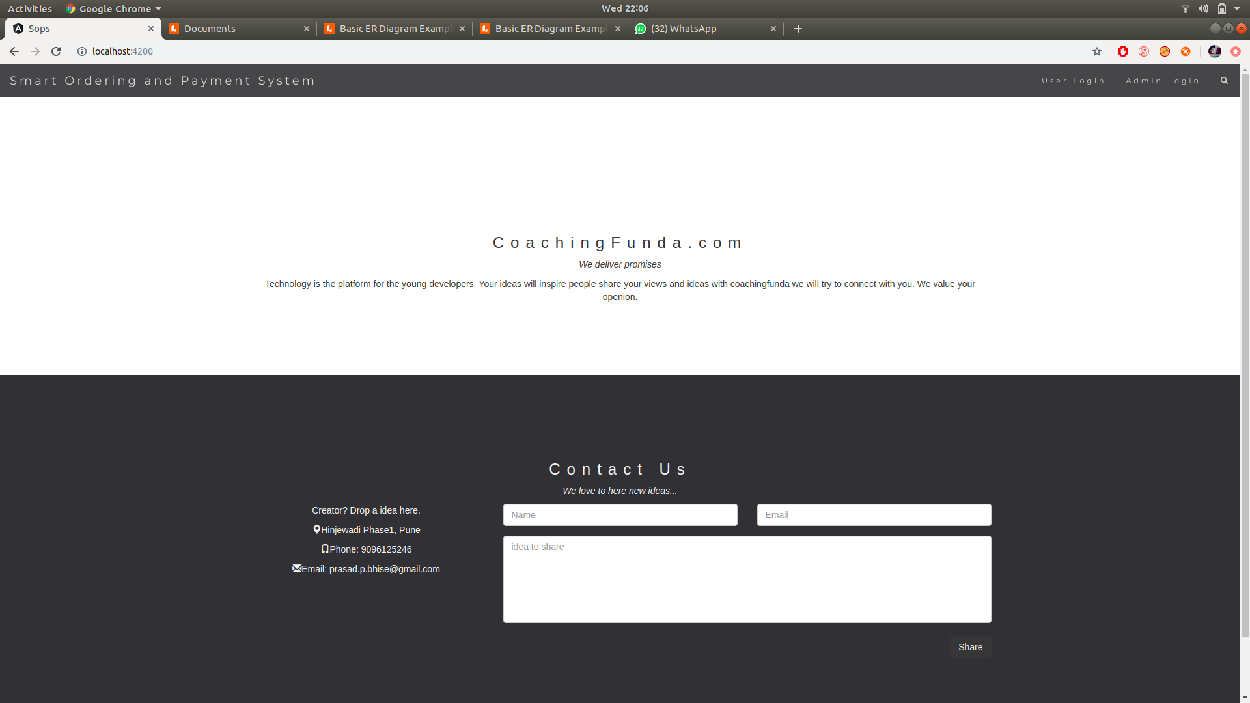

LoginPopup:
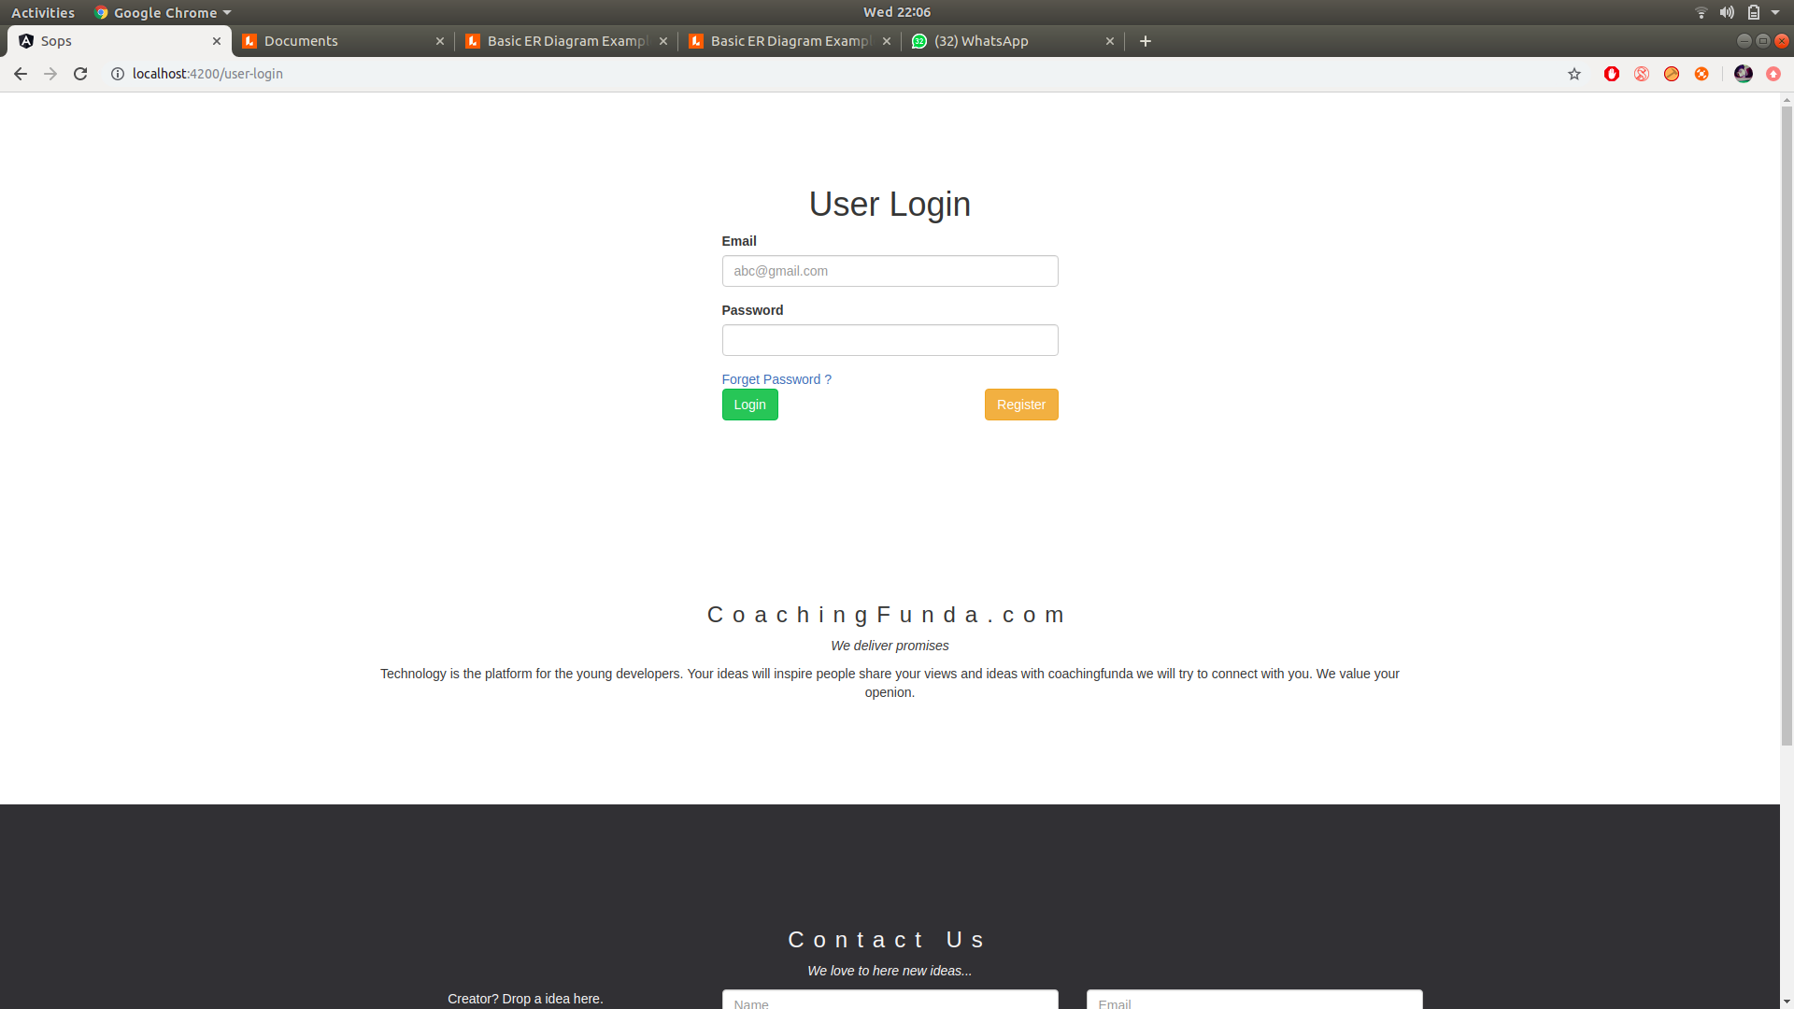

Administrators Login:
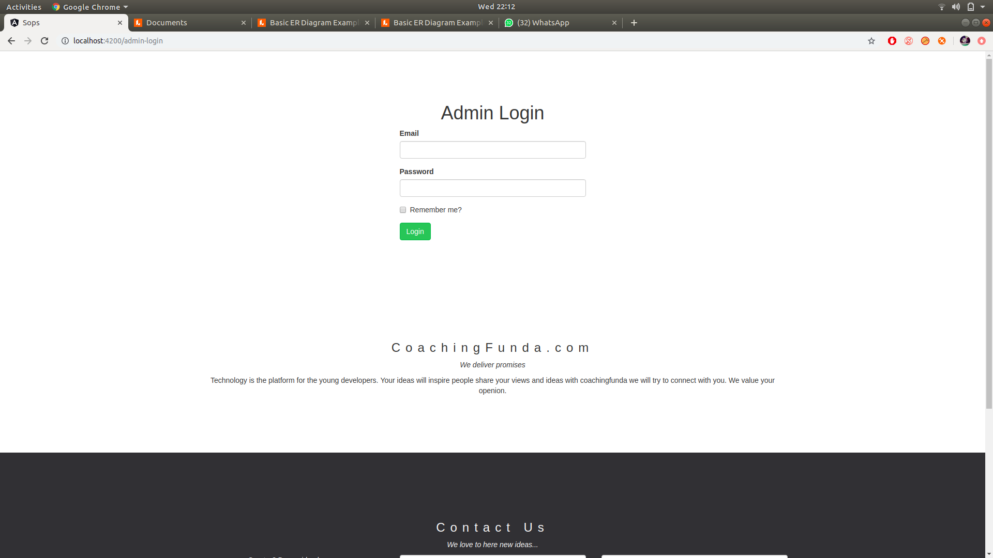

User Registration:

Add Airline

AddFlight

Delete Flight

MenuList:

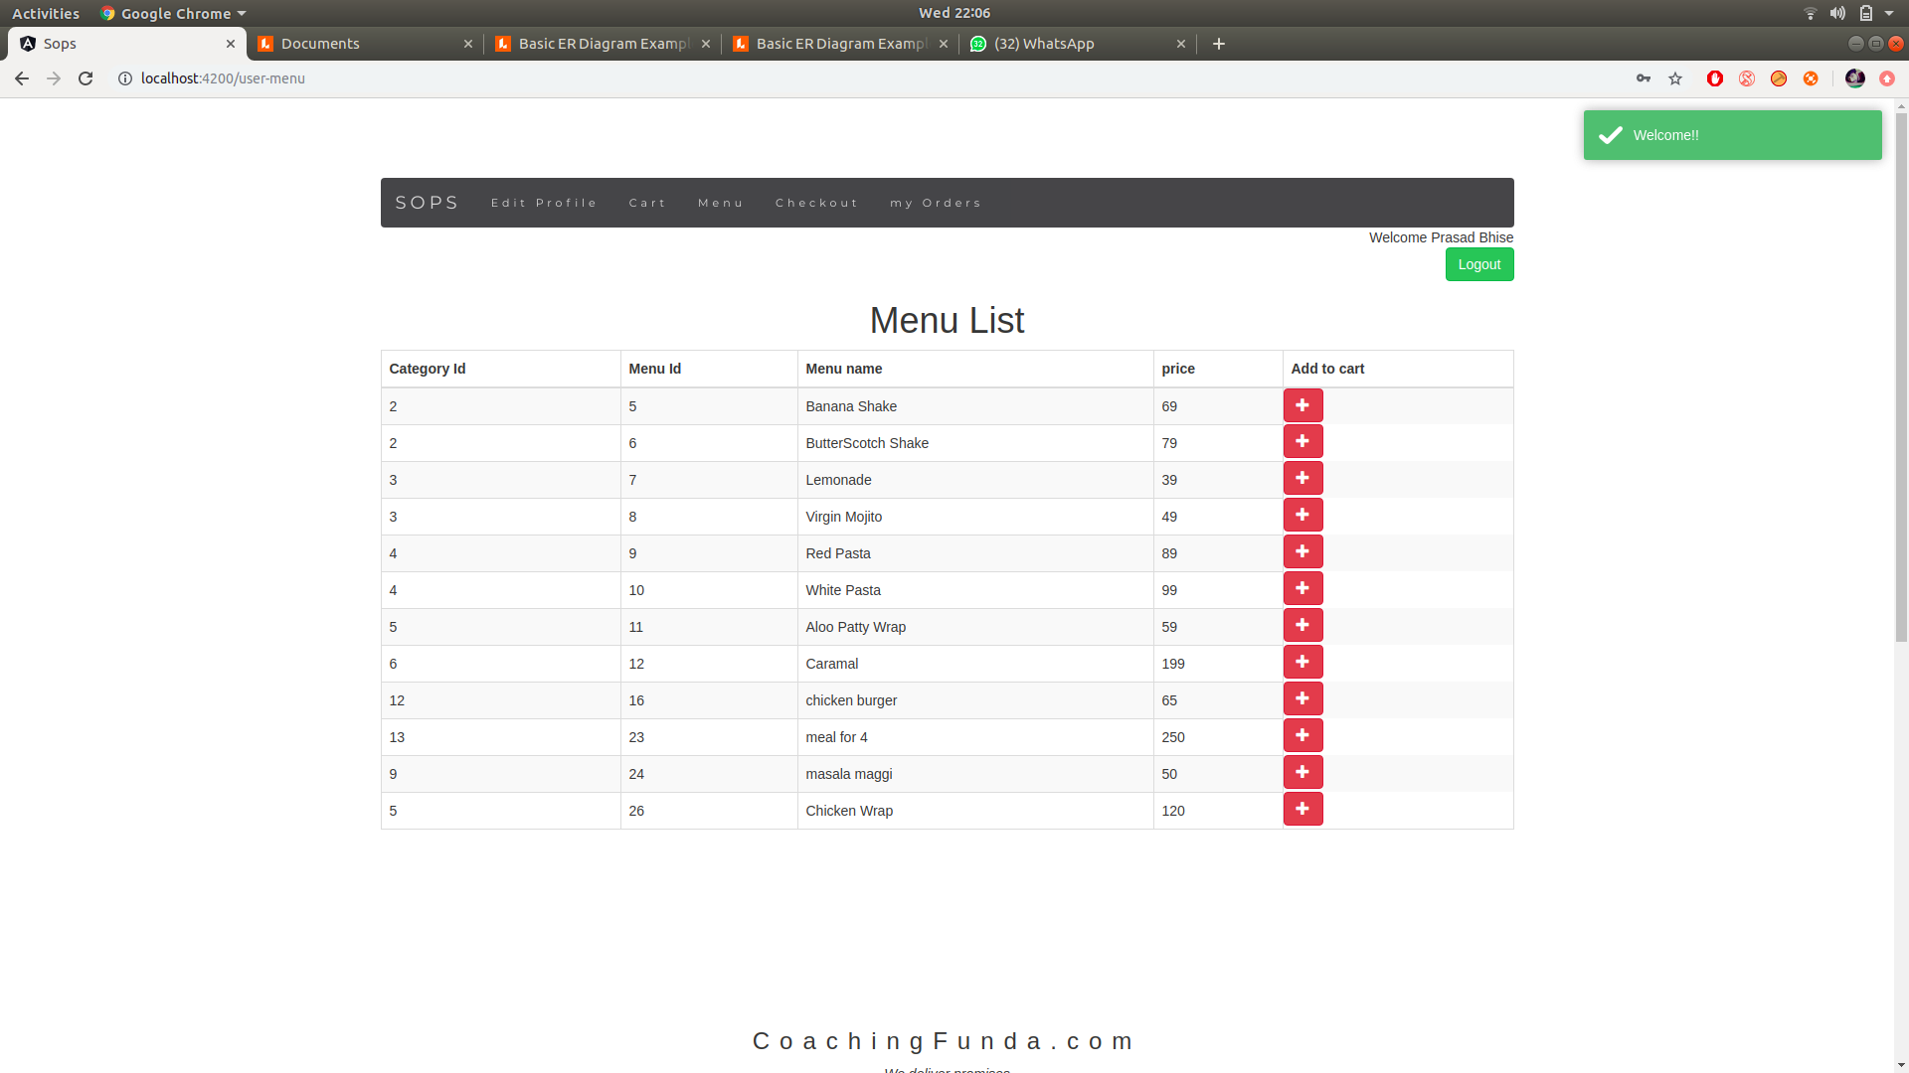

cart:
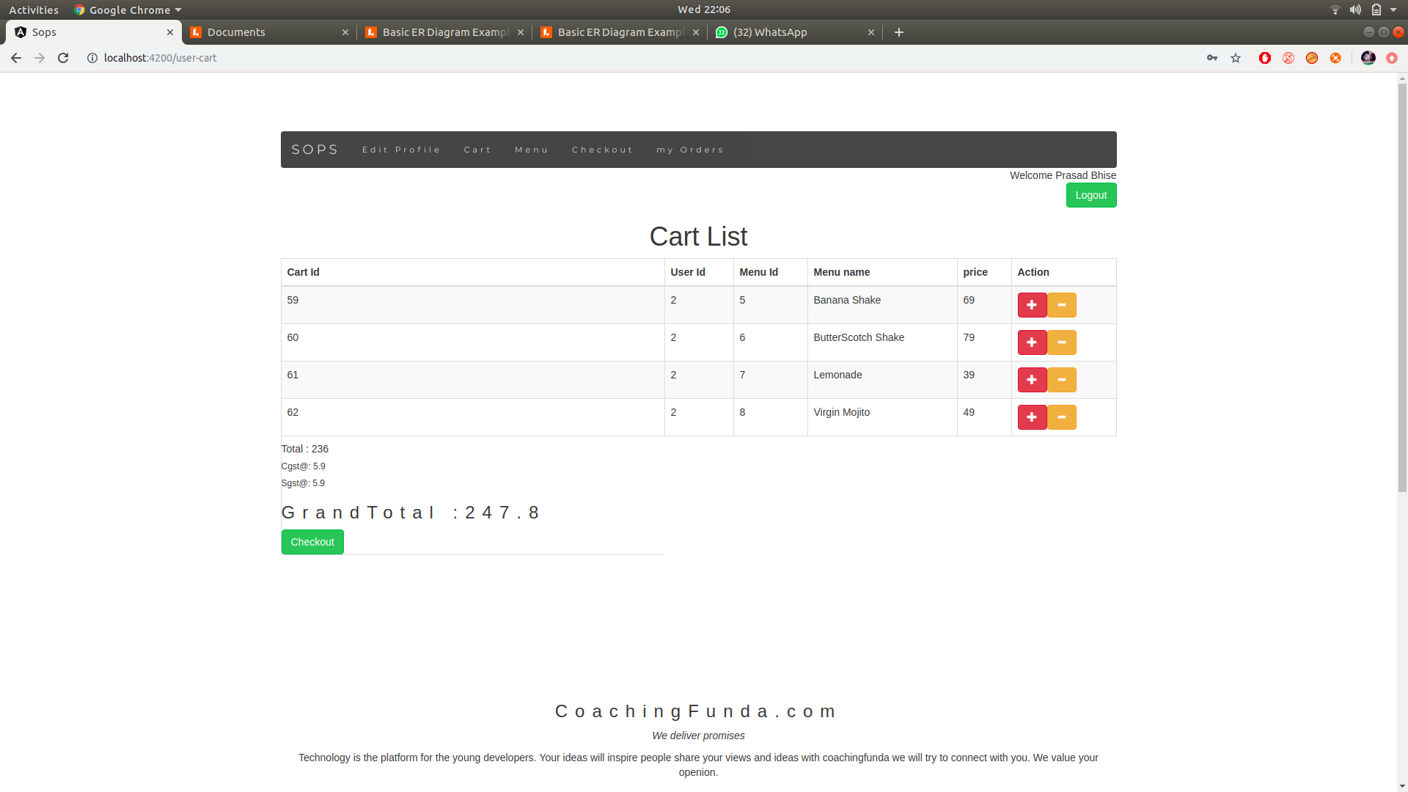

Checkout:
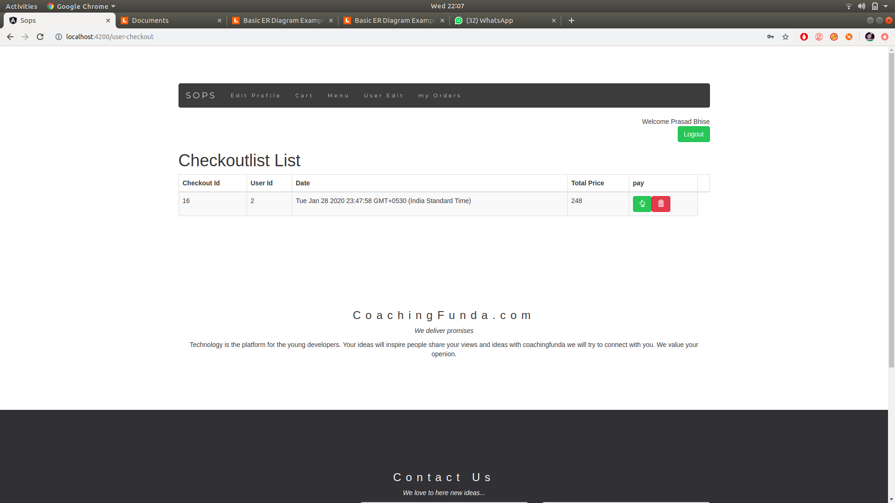

Payment:

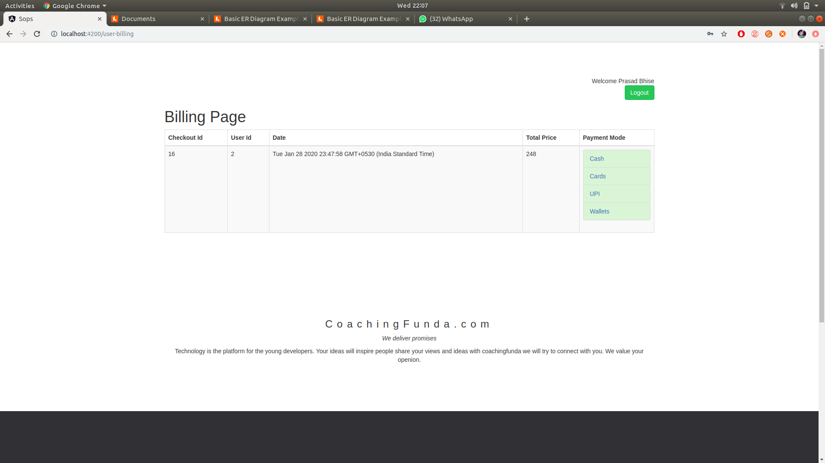

Edit user:
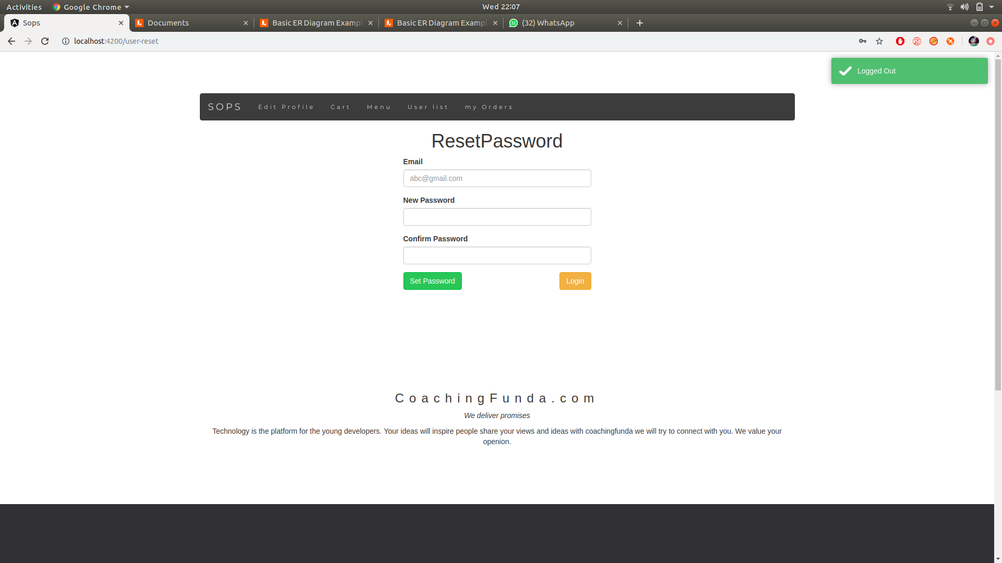

Feedback form:

7.REFERENCES:

http://www.google.com

http://www.airIndia.com

http://www.webdevelopersjournal.com/

http://www.lufthansa.com

http://www.w3.org

http://www.wikipedia.org

http://www.delta.com

http://www.priceline.com

